**Bank Loan Project**

1. Bank Loan Report

* **Key Performance Indicators (KPI’s)**

1. **Total Loan Applications**

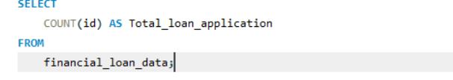

**Answer:**

1. **MTD Loan Applications**

**Answer:**

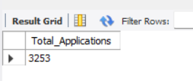

1. **Total Funding Amount**

**Answer:**

1. **Month To Date Total Funding Amount**

**Answer:**

1. **Total Amount Received**

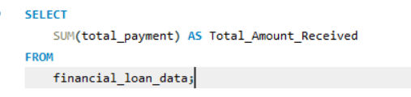

**Answer:**

1. **Average Interest Rate**

**Answer:**

1. **Average DTI**

**Answer:**

1. **MTD Average DTI**

**Answer:**

**Good Loan Issued**

* **Good Loan Percentage**

**Answer:**

**Good Loan Applications**

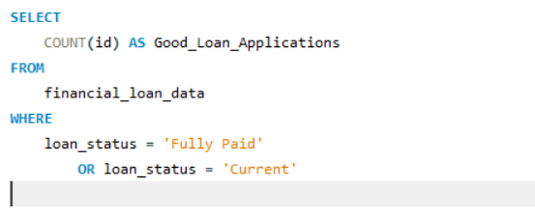

**Answer:**

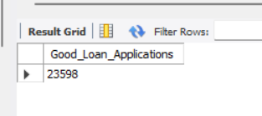

* **Good Loan Total Amount Funded**

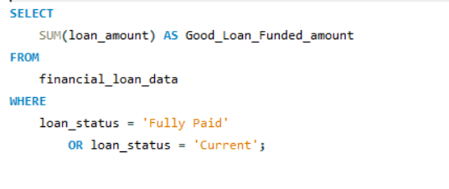

**Answer :**

* **Good Loan Total Amount Received**

**Answer:**

**Bad Loan Issued**

* **Bad Loan Percentage**

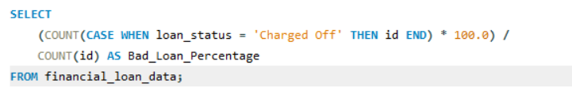

**Answer:**

* **Bad Loan Applications**

**Answer:**

* **Bad Loan Funded amount**

**Answer:**

* **Bad Loan Amount Received**

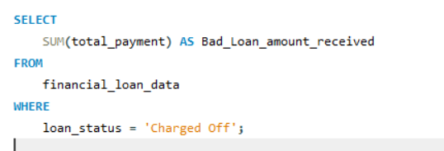

**Answer:**

**Loan Status**

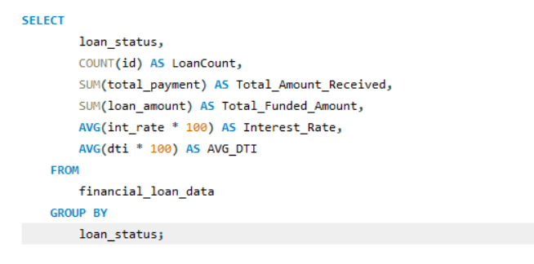

**Answer:**

1. **Bank Loan Report /Overview**

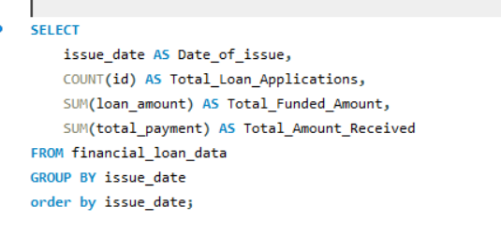

**Answer:**

1. **State Wise Bank Loan Report**

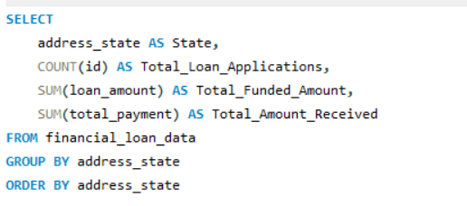

**Answer:**

1. **Term wise Bank Loan Report**

**Answer:**

1. **Employee Length wise Bank Loan Report**

**Answer:**

1. **Home Ownership wise loan report**

**Answer:**

